Question 1)

Opinions of people and ratings in the same order.(rater 1,rater 2,rater 3)

**Phone Oneplus 6**

Good Camera, nice display but I did not like the battery lifetime of the device. Constant android updates are also a plus. But the cost is high.

**Ratings:Positive,Positive,Negative**

**Iphone**

I did not like the OS of the phone. Overall the phone was very overpriced. I liked the UI though The phone is also quite sleek and lightweight.

**Ratings:Negative,Negative,Neutral**

**Pixel 3**

I liked the constant stream of timely android updates. I liked the display but I did not like the default UI. Also the phone was a bit towards the pricey side.

**Ratings:Neutral,Positive,Neutral  
  
Cohen’s Kappa.**

It is a robust expert rating system. It takes the chance element in consideration while devising the relations between the sentiments. This leads to generally more accurate results. However calculating the agreement due to chance is not usually straightforward.

Building the matrices we get

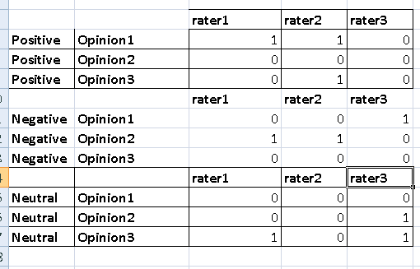

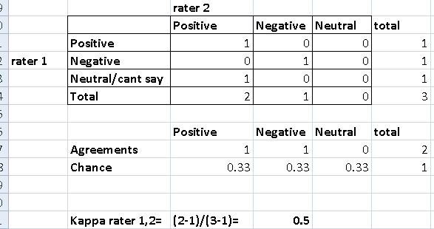

Between rater 1 and 2 cohens kappa calculations

Kappa rating(0.5) for these raters is moderate. So these raters somewhat agree with each other

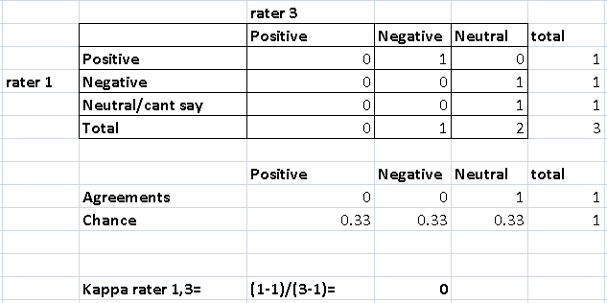Kappa rating between rater 1,3=0

This implies any agreement between these raters is only based on chance. These raters have no relation between each other and only based on chance they have same reviews.

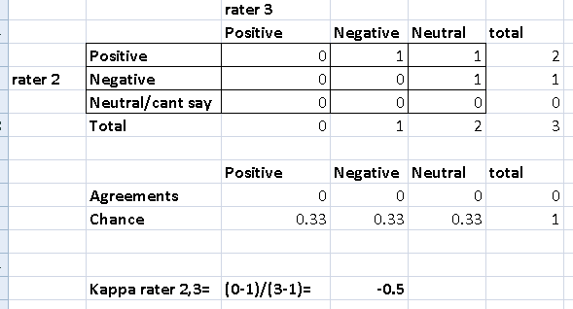Kappa rating between rater 2,3=**-0.5**

This negative rating implies that the raters actually strongly disagree with each other . It is quite likely that both raters will always give opposite/conflicting ratings.

**Pearsons Rho :**

It is used to find how strong a linear relation is between two variables x,y  
For Pearsons calculation you just need to calculate the squares x^2,y^2,xy and the sum of x,y

Excel however has a Pearson function that does the job .

Due to the ratings of just yes or no, and small dataset

For pearsons coefficient I got the same results

Rater1 ,rater 2 pearson =0.5 (strong positive relation)

Rater 1,rater 3 pearson=0(no relation)

Rater 2,rater 3 pearson=-0.5(Negative relation)

**Question 2**

Sentiments obtained from : <http://www.cs.uic.edu/~liub/FBS/opinion-lexicon-English.rar>

**1)Words chosen in positive sentiment list;**

Amazed,Famous,Amusing,appropriate,entertain,ergonomical,faith,fancy,fanfare,gratification

**2)Words chosen in Negative sentiment list:**  
Absurd,Brainwashed,Brute,collapse,contradict,allege,alter,confront,confuse,costly,comical

**3)**Positive words analysis and how they can be used in opposite valence(brackets indicate chances of negative usage)

Amazed (very likely to be positive) . I am amazed how stupid Mr XYZ is .

Famous(positive) How do people like Mr XYZ even get famous???

Amusing(positive) The only thing amusing about Mr XYZ is people thinking he is a good comedian.

Appropriate(slightly positive) One can’t simply expect Mr XYZ to act appropriately in a formal setting.

Entertain(positive) Why should I vote for Mr XYZ? Go on entertain me..

Ergonomical(positive) Ergonomical chairs are a fad we should worry about more pressing issues.

Faith(positive) She has faith only in herself

Fancy(seems negative) Why dress so fancy when you can just slap a tux on.

Fanfare(seems negative) Fanfare crowded Mr XYZ and broke his cars windows to get a glimpse of him.

Gratification(negative connotations ) Everything nowadays is based on instant gratification , it is sick.

From these sentences we can see that if a positive word is associated with very negative words or words like ‘only’ they can easily mean negative words. If someone is asking questions like why or in the case of too much of the positive word the sentiment can be considered as negative as person is sick of it. Sarcasm is another issue.

**4)**Negative words that can be considered as positive.

Absurd(negative) It is absurd how underrated show XYZ is

Brainwashed(highly negative) Brainwashing is just a fad term, it will die soon.

Brute(slightly negative) The brutish performance of the villain Mr XYZ in the movie XYZZ was amazing.

Collapse(slightly negative)The collapse of communism is the day Russia celebrated .

Contradict(highly negative) The judge’s sentence contradicted the actual story, Hence she was let go.

Allege(highly negative) Don’t allege me of being flirty

Alter(seems neutral) Only you can alter your destiny.

Confront(seems neutral) I confronted the thief and he was apprehended immediately.

Confuse(seems neutral) This text analytics assignment isn’t confusing at all!

Costly(negative) The costly tickets were completely worth the experience.

Comical(seems positive) Comical performance of Mr XYZ in movie XYZZ was highly applauded by critics.

It seems it is harder to change the valence of highly negative words. Whether two negatives can combine (confront thief) and form a positive is hard to computationally do.

Valence of words that are slightly negative can be changed by words like ‘but’ .Example Negative statement ‘but’ very positive statement due to first statement.

**Question 3**The classifier seems to be based on Naïve Bayes. A cutoff of 75% is set below which features are trained and rest are used for testing.

Measures for all words including stopwords

accuracy: 0.77344336084021

pos precision: 0.7881422924901186

pos recall: 0.7479369842460615

neg precision: 0.7601713062098501

neg recall: 0.7989497374343586

This code was added to remove stopwords:

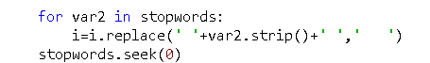

Here stopwords is the filehandle of the stopwords.txt file provided.

Surprisingly after removing stopwords:

accuracy: 0.7633158289572393

pos precision: 0.7611607142857143

pos recall: 0.7674418604651163

neg precision: 0.7655068078668684

neg recall: 0.7591897974493623

The values of all measures decreased. After analyzing the stopwords provided I realized that many of the stopwords actually conveyed very important factor for judging the sentiment. Recall however increased as the number of relevant items increased proportionally, While precision reduced as false positives were more.

There are many such words that are vital for determining sentiment. Some examples: isn’t ,no ,nor ,not only ,wasn’t and wouldn’t. These words were considered as stopwords and filtered out by the program. This leads to some of the reviews having negative and positive words judged as just a positive sentiment( I wouldn’t recommend this movie- becomes: I recommend movie). Setting the filter properly can affect these results. However I don’t think we should remove stopwords from the dataset. Only the most obvious ones like “the, A , I” can be safely removed.  
  
Here is another example of an excerpt of a review

“….provides a porthole into that noble , trembling incoherence that defines us all .”

This obviously shows a strong positive response.

However after removing stopwords:

“….provides porthole noble, trembling incoherence defines us.”

This doesn’t imply a strong positive response. It actually feels a bit negative. This will possibly be classified wrongly. Here words “that” and “all” did actually help convey the sentiment.